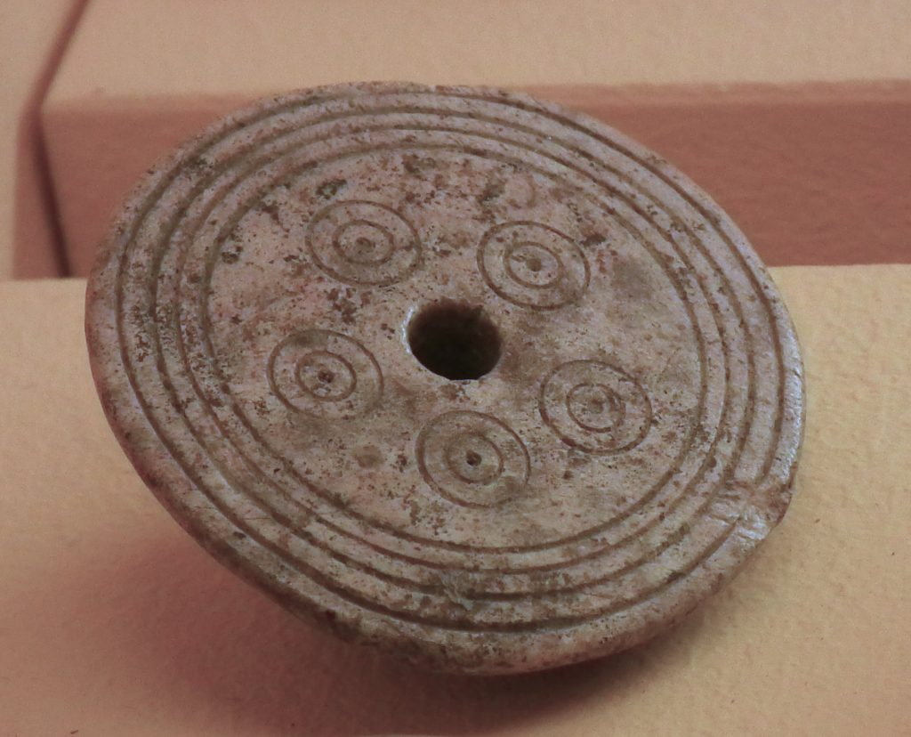Neolithic spindle whorl made of antler (Italy)

Ceramic spindle whorl, cone-shaped. Italy. Middle to Late Bronze Age 1650-1150 BC

Neolithic spindle whorls, Italy.

Spindle whorls, 2300-1050 BC, North Cyprus

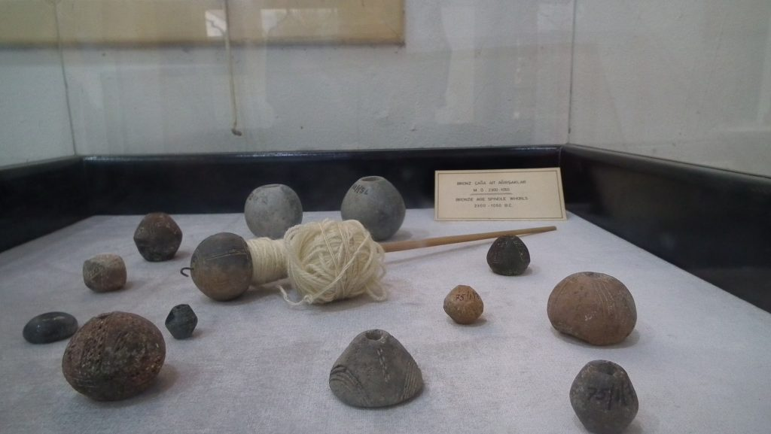

Neolithic spindle whorls, Iskele Archaeological Museum, Cyprus

