Spinning Bees and the Contribution of Women in the American Revolution
(from N-Y Historical Society, https://wams.nyhistory.org/settler-colonialism-and-revolution/the-american-revolution/)
Before the outbreak of the American Revolution, British colonists protested new taxes by refusing to buy things that were shipped from England. Women were important to these boycotts, because they were in charge of all the purchases made for colonial homes and families. They also had the skills to make homemade substitutes for British products.
In New England, women joined in the boycotts by going to spinning bees. At these events, women would set up spinning wheels and keep each other company while they spun yarn that could be woven into fabric. The fabric made this way was called “homespun.” Wearing clothing made from homespun fabric was one way to demonstrate your support for the rights of the colonies in the 1760s and 1770s.
Most spinning bee participants were young, unmarried women, because they were the people who had the spare time for such work. Spinning was considered an acceptable way for women to express their political opinions, because it was within the bounds of traditional women’s work.
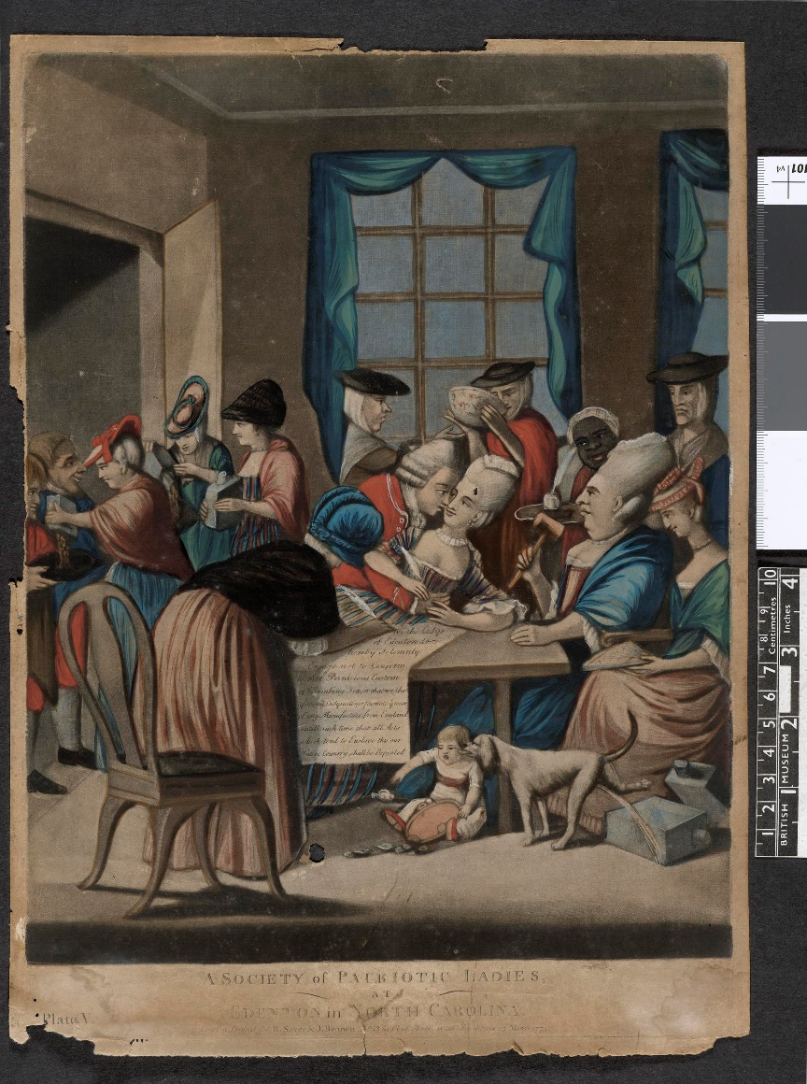
The Edenton Tea Party
In 1774, fifty women in Edenton, North Carolina, signed and published a statement [in The Virginia Gazette] declaring their intention to boycott all British goods. It was the first women’s public collective political action in American history.
(Left: A British cartoon satirizing the Edenton Tea Party participants)
“As we cannot be indifferent on any occasion that appears nearly to affect the peace and happiness of our country, and as it has been thought necessary, for the public good, to enter into several particular resolves by a meeting of Members deputed from the whole Province it is a duty which we owe, not only to our near and dear connections who have concurred in them, but to ourselves who are essentially interested in their welfare, to do everything as far as lies in our power to testify our sincere adherence to the same; and we do therefore accordingly subscribe this paper, as a witness of our fixed intention and solemn determination to do so.”
The Virginia Gazette (Williamsburg, VA: November 3, 1774).
The Edenton Tea Party was a landmark, not because of the stances taken — boycotts were common across the 13 colonies — but because it was organized by women. Women in the colonies were generally invisible in politics, but the Edenton Tea Party was one of the first instances of political action organized and enacted by women.

Predating the 1774 North Carolina Edenton Tea Party:
The patriot spinning bees held in Massachusetts & New England were a method of choice for ladies to protest harsh British regulations and restrictions, and to contribute to the Rebel cause:
(from the Massachusetts Historical Society, https://www.masshist.org/database/viewer.php?item_id=390&pid=2 )
This article published in the Salem, Massachusetts, newspaper [The Essex Gazette] in May 1769 describes the productivity and patriotism of women spinning linen yarn in Newport, Rhode Island and Huntington, Long Island in New York.

Made in America
If the non-importation and non-consumption movements are to succeed, colonists must find American alternatives to imported luxuries. Newspapers publish recipes for brewing tea from local herbs, and women are urged to wear homespun colonial garments in place of British silks and calicoes. Spinning and weaving bees become more than just social outlets--the production of cloth is now a sign of patriotism.
To examine all four pages of this newspaper, please see the online display of The Essex Gazette, 23-30 May 1769.
TRANSCRIPT OF NEWSPAPER ARTICLE . . .
[column1 (section 1)]back to top
March 30.
It was early conceived by the most sagacious and
knowing Nations, that a Number of Females had always determined
the Condition of Men, by means of their Spinning Wheels : And
Virgil intimates, that the Golden Age advanced flower, or faster
as they spun.
" Talia fæcla, suis dixerunt, currite Fusis
-- [Many hyphens are on this line in the original article.] Parcee."
And had the Ladies, in every Age since, ruled in this laudable
Way, perhaps some nations would be in a far better State than
they now are ; but be that as it will, I presume there never was
a Time when, or a Place where, the Spinning Wheel could more
influence the Affairs of Men, than at present, in this and the
neighbouring Colonies; --- or sooner produce a golden Age. The
following Relations and Instances amongst a multitude of others, in
all the Colonies, of the Industry and Frugality, of American La-
dies, must exalt their Characters in the Eyes of the World, and
serve to shew how greatly they are contributing to bring about the
political Salvation of a whole continent.
A Gentleman at New-Port writes -- "As I am a very great
Lover of Liberty, of Beauty, of Music, of my Country, and of all
those who endeavour to promote and establish, by good Oeconomy,
its Wealth, Peace, Prosperity and Tranquility, and being at the
sign of Pitt's Head in this Town, on Tuesday last, was extremely
pleased by having Admittance into the Company of Eleven of the
Daughters of Liberty, Ladies of Character, and Lovers of British
Freedom, and Industry ; each being laudably employed in playing
on a musical Instrument, called a Spinning Wheel, the Melody of
whose Music, and the Beauty of the Prospect, transcending for
Delight, all the Entertainments of my Life. I was still more pleased
with the Ladies Company, (when by Inquiry) I had learnt more
of their Love of Liberty, and strict Attachment to their Country's
Welfare, and of their Determination of preserving in such laudable
Exercise and good Oeconomy, as is a Credit to the fair Sex, and an
Honour to America.
For I found that, as these Daughters of Liberty delight in each
other's Company, they had agreed to make circular Visits to each of
their Houses, and in order to excite Emulation in serving their
Country, promoting Temperance and Industry, had determined to
convert each Visit into a spinning Match, and to have no Enter-
tainments but what is the Produce of their own Country ; and to
appear as much as possible clothed with our own Manufactures,
and that more especially which is the Effects of their own Labour
--- The abovesaid Ladies spun between 6 o'Clock in the Morning,
and 6 o'Clock in the Evening, 37 skeins and 15 Threads which,
upon an Average make three Skeins five Knots and five Threads."
March 31.
A Gentleman in James- Town, also writes -- " As a
Proof that the Daughters of Liberty in this Town, are not less zea-
lous in promoting American Manufactures, and the Cause of con-
stitutional Liberty, than those of Newport, I can assure you that
eighteen Ladies, of good Fashion and Character, of this Town,
and two from Newport, met on Monday last at the House of Mr.
James Carr, junr. in order to try their Dexterity, at a spinning
Match : And notwithstanding one was but eleven Years old, and
[column2 (section 2)]back to top
another left off at about two o'Clock, they spun between Sun-rise
and Sun-set 78 Skeins and nine Knots of choice Linen Yarn ;
each Skein containing 15 Knots, and each knot 40 Threads. -- I
will only observe to the Honour of the above mentioned twenty
in particular, and the fair Sex in general, that were the Gentlemen
really as sincere, and as much in earnest in promoting Frugality,
Industry, and all other Virtues, as the Ladies are, there is not the
least Doubt, but we should soon free ourselves from the Burthens
with which we are now oppress'd, and lay the Foundation of
American Liberty on a Basis not to be shaken by any Power on
Earth !"
We are informed from North-Kingston, that last Friday, eleven
neighbouring young Ladies met together, at the House of John
Congon, Esq; in that Town, upon a Spinning Match ; where they
began to spin about Sun-rise, and spun about forty six fifteen knot-
ted Skeins of good Linen Yarn, and left off about five in the Af-
ternoon of said Day ; when about as many young Gentlemen, as
there were Ladies, came to said House, and opened as a fine Ball, as a
Recompence to the Ladies, for their Industry.
And from Newport, that lately eleven Ladies met at the House
of Mr. Stephen Tripp, on the Point, and spun 34 Skeins and
seven Knots of good Linen Yarn. -- Though the Quantity they
spun, was not so great as has been produced by some spinning
Matches, consisting of the same Number ; yet I believe it may
with Truth be said, that it exceeded in fineness, as the whole
weighed but 4lb. 5 oz. which is eight Skeins to the Pound. -- To
the Honour of those Ladies, it ought to be mentioned, that they
refused the Regale of the destructive Bohea, and were most of them
dressed in Cloths of their own spinning, and the others are resolutely
determined to follow the laudable example as soon as possible.
April 1.
We are also advised from Huntington on Long-Island,
that very lately a Company of young Ladies belonging to that
Town, to the Number of sixteen, met to spend the Day together,
not in idle Dissipation, (as is too often the Case,) but with a truly
laudable Design of promoting Industry, for they had no sooner met
together, but to divert themselves, they each took their Spinning
Wheels and applied themselves so closely and with that Dexterity
that at the Close of the Day, they had spun one hundred and seven
Skeins, in each Skein were ten Knots, weighing thirty two Pounds of
very good Linen Yarn. The Ladies were all decently clad in Home-
spun, the Manufacture of their own Town ; who like true Female
Patriots, shewed by their Conduct, that they despised to dress with
the Manufactures of a Country that is endeavouring to enslave us.
It also appeared, that a Female Patriotism was predominant in their
Conduct, when the Tea Table was introduced ; for instead of
making use of any foreign Tea, (which is become more nauseous
since loaded with an unconstitutional Tax,) they substituted a Tea
the Growth of that Town, called Ever-Green, which for its plea-
sant Flavour, and many excellent Qualities, is preferred by many to
the best Green Tea.

